Hackos Chapter 1 notes (slideshow on canvas)

(Module 3 assignment)

Defining quality in technical publications

* "Quality Dilemma" - (pp. 11 - 12)
* "Technical publications add value" (pp. 12 - 14)
* "Standards as quality" (pp. 14 - 15)
* "People as quality" (pp. 15 - 18)
* "Tools as quality" (pp. 18 - 19)
* "Process as quality" (pp. 19 -20)
* "Management as quality" (pp. 20 - 24)

Quality dilemma

* "The process of designing and developing technical publications is custom work. The most significant parts of the development effort focus on accommodating human learning processes. Whenever you deal with human behavior, as you always do in technical publications, you are treading on slippery quality ground as far as defining quality goes." (pp. 10-11)

“Quality is relative”

* Multiple project stakeholders may seek to define quality. For example, product owners may define quality as "Rapid development" and "low cost" (Hackos, 1994, p. 11).
* Marketers may prioritize the "attractiveness" of a publication over cost (Hackos, 1994, p. 11).
* For our purposes, quality metrics will be defined--following Hackos (1994) – as technical publications that help users achieve their goals while using the publications.

Technical Publications Add Value

* As technical writers, your role is to add value to organizations by creating high quality technical publications. You also may need to justify your documentation projects by discussing how your work adds value.
* For Hackos (1994, p. 12 -13), technical publications add value by:
  + making information accessible to users
  + making users more productive faster
  + increasing the range of use
  + reducing the cost of troubleshooting or customer service
  + reducing maintenance costs
  + increasing sales

Standards

* To create high quality technical publications, technical writers need to adopt standards.
* Standards include (qtd directly from Hackos, 1994, p. 14):
  + Format and typography
  + Writing style
  + Use of special terminology
  + Spelling and abbreviations

CRAP Principles

* Contrast
* Repetition
* Alignment
* Proximity
* **Adapted from Robin Williams’ (2015) *The non-Designer’s Design book.***

Applying CRAP

* The following examples are derived from IBM”S (2013) *Commitment Control Manual*

Contrast

* Contrast foregrounds distinctions between elements, which can be used as a means to organize page layouts.

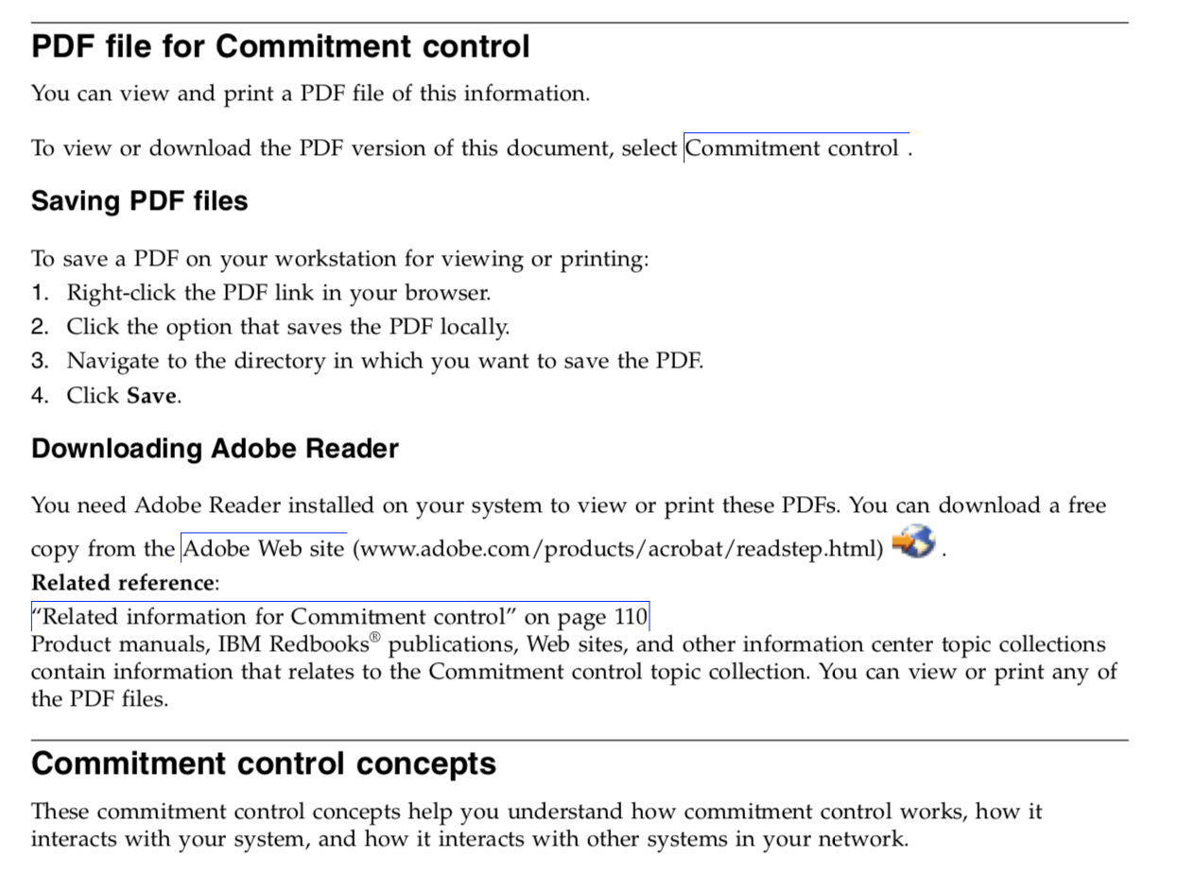

Repetition



* The REPETITION of nested headings across the page provides visual consistency to the information on the page. This consistency allows readers to more easily process the relationships between concepts presented in the page.
* “Saving PDF files” and “Downloading Adobe Reader” are not the same tasks, although they are related/necessary to to accomplish the higher order task of accessing the PDF file for the IBM commitment control manual.

Alignment

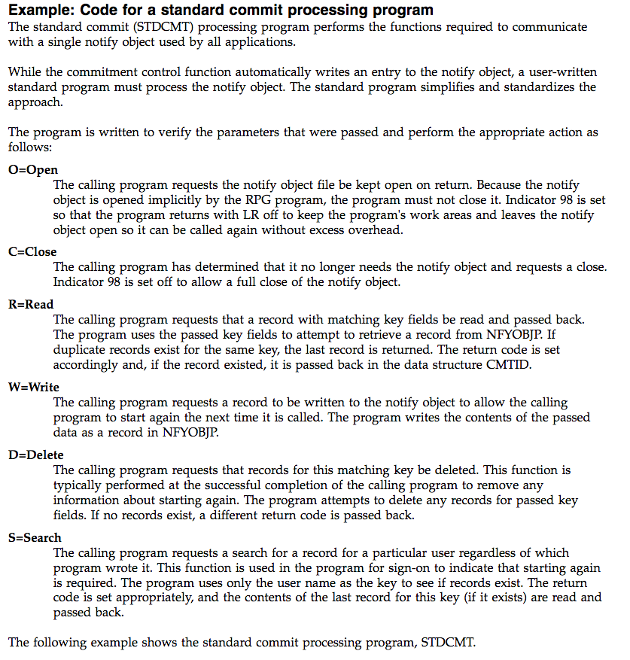

* Alignment can be used to create consistency among sections AND differentiate sub-sections from each other.



Proximity

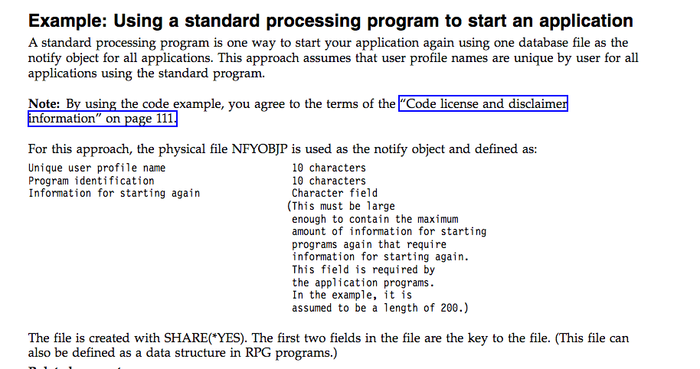

* Proximity indicates relatedness among elements. Elements grouped together on a page should be related. Lack of proximity between elements can indicate lack of relatedness.

People

According to Hackos (1994, p. 17), documentation projects benefit from the following skills (qtd directly):

* understand the technology they are writing about.
* know how to interview customers, technicians, subject matter experts, working well with all these diverse groups.
* Understand the production and printing process
* Can effectively negotiate with developers and marketing specialists

Cross-functional teams

* As a technical writer, your expertise is in writing--in your ability to translate technical information into useable language for multiple audience and create writing that instructive and useful.
* Much of your work is gathering information from various experts working in cross-functional teams (teams with various members of different expertise). Thus, you are a mediator between project principals.

Tools

* Tools refer to the equipment that allow us to manage projects and produce documentation. These include data collection tools such as forms or surveys, writing software such as Word, Excel, or Markdown, and publishing tools such as Github, or mkdocs.

Process

Standards and tools are incorporated into processes or workflows. Processes ensure quality when they (Hackos, 1994, p. 20):

* allow you to produce high quality technical publications consistently.
* gives you the ability to estimate a budget and schedule and meet your commitments
* allows you to meet the expectations of your customers in predictable ways
* \*\*it also makes it less taxing if you have a tried-and-true process to apply to projects.

Management

In addition to establishing processes that will allow you to produce consistent technical documentation, you also need a method/workflow to manage projects--i.e., keep processes on track.

For our purposes, documentation management or project management chiefly involves the creation of plans that outline the trajectory of projects, sets development milestones, and creates assessments:

* Information Plan (Project 2)
* Content Specification Plan (Project 3)
* User Experience Testing Report (Project 4)